

**Faculty:** IT

**Course Name:** Digital Computer Fundamentals

**Course Code:**  MATH 8127

**Lecturer:** Kundan Kumar

**Group Members:**

* MUTANGANA Joseph 29061

**Report:** **Sequential circuit group assignment**

**Q1**. A sequential circuit is a type of digital circuit where the output depends not just on the current inputs, but also on the past inputs

A sequential circuit gives output based on the current input + past states.

Sequential circuits include memory elements like flip-flops or latches.

These store the previous state, allowing the circuit to "remember" what happened before.

**Q2.** Different between sequential circuit and combination of circuit

|  |  |  |
| --- | --- | --- |
| **Feature** | **Combination of circuit** | **Sequential circuit** |
| Memory | No memory | Has memory |
| Outputs Depends on | Current input | Current inputs + Previous inputs |
| Examples | Adders, Multplex | Filp-Flops, counters, registers |
| Timing | Instantaneous | Depends on clock or input change |

**Q3. Types of Sequential circuit**

Types of Sequential Circuits Sequential circuits can be broadly categorized into two types based on how they handle state changes:

1. **Synchronous Sequential Circuits** 
   * + - * Operate in sync with a clock signal
         * State changes occur only on the clock pulse
         * More predictable and easier to design/debug
         * Commonly used in digital systems

**Examples of synchronous circuits:**

1. **SR Flip-Flop (Clocked version):**

* Two inputs: S (Set), R (Reset)
* If S=1 and R=0 → Output is set to 1
* If S=0 and R=1 → Output is reset to 0
* If S=R=1 → Invalid state (undefined)

1. **D Flip-Flop:**

* Single input (D) and a clock input
* On clock edge, the output becomes equal to D
* Eliminates invalid states of SR

1. **JK Flip-Flop:**

* Improvement over SR Flip-Flop
* Inputs J and K If J=K=1, the output toggles
* No invalid state

1. **Counters (using flip-flops):**

* Count sequences (binary counting)
* Made by connecting flip-flops in series
* Used in clocks, timers, digital counters

These components change state only on a clock edge (like rising or falling edge).

**2.Asynchronous Sequential Circuits**

* Do not use a clock signal
* State changes happen immediately with input changes
* Faster but more complex due to potential for glitches or race conditions

**Examples of asynchronous circuits:**

1. **Basic (unclocked) SR Latch:**

* Simple memory element without a clock
* Directly responds to S and R inputs

1. **Asynchronous Set/Reset circuits:**

* Often used to reset systems when powered on
* Triggered by inputs, not clock pulses

These are useful for simple control logic, but are less common in modern large-scale systems.

**Q4. Design of SR Flip-Flop**

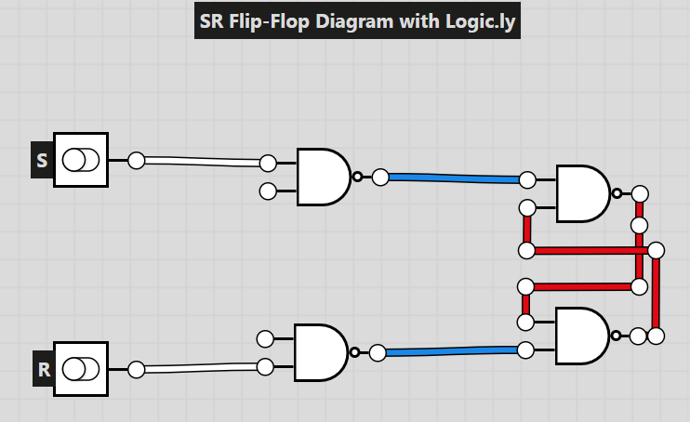

**Truth table of SR flip-flop with NAND**

|  |  |  |  |  |
| --- | --- | --- | --- | --- |
| **S** | **R** | **Q** | **Q’** | **State** |
| 0 | 1 | 1 | 0 | Set |
| 1 | 0 | 0 | 1 | Reset |
| 0 | 0 | Invalid | Invalid | Invalid State |
| 1 | 1 | Previous State | ________ | No change |